Meeting Summary
Date: Tuesday, May 8, 2018
Location: Norfolk Town Hall, 1 Liberty Lane
Attendees: Richard McCarthy, Norfolk
Amy Love, Franklin
Jim Kupfer, Bellingham
Georgia Wilson, Hopkinton
Gino Carlucci, Sherborn
David Loutzenheiser, MAPC

Recorded by: Kasia Hart, SWAP Coordinator

Community Exchange
- Welcome to Georgia Wilson, new Principal Planner in Hopkinton! Georgia is diving right in to Town Meeting, which started on Monday May 7.
- Norfolk is also getting ready for Town Meeting, which was scheduled for Tuesday May 8. Issues to be addressed include a ban on recreational marijuana, affordable housing bylaw changes, and other minor articles.
- There are a variety of small projects currently happening in Franklin, including some changes to the zoning map to better align lot lines. The Town is also working on a senior overlay bylaw, and is exploring the possibility of allowing residents to have chickens on their property.
- Sherborn had their Town Meeting last week, and items that passed include an accessory dwelling bylaw and an outdoor entertainment bylaw. An open space development bylaw did not pass. Additionally, the Town is working on the developing a connection to the Upper Charles Trail.
- Bellingham recently unveiled the Town’s community garden. Additionally, the Town is working on developing its connections to the Southern New England Trunkline Trail (SNETT), as well as exploring some zoning changes to match existing infrastructure.

Update from MAPC
- Please be advised that MAPC will be following up with all communities to enlist your help in advocating for DLTA as the House and Senate work to develop a budget for the state. Stay tuned for more information!

Norfolk Rail Trail Right of Way Walk

David Loutzenheiser, MAPC Senior Transportation Planner, led a walk of the Norfolk Rail Trail right of way, which runs from the Millis town line, connects up with Medway Branch Road, and then continues down to the Norfolk Commuter Rail Station. This was a timely site visit since not only is May Bike Month, but MAPC also recently unveiled is LandLine report, which envisions a regional network of 1,400 miles of trails and greenways in the region.
Some photos from the day are below. To see a few more, please check out this folder here.

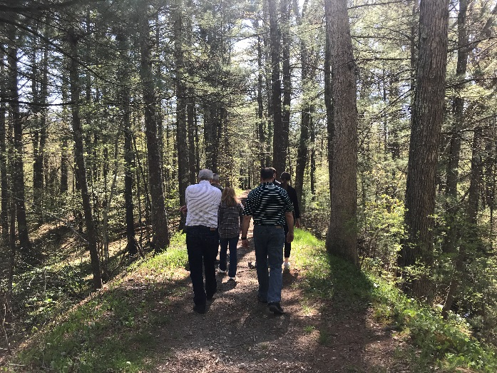
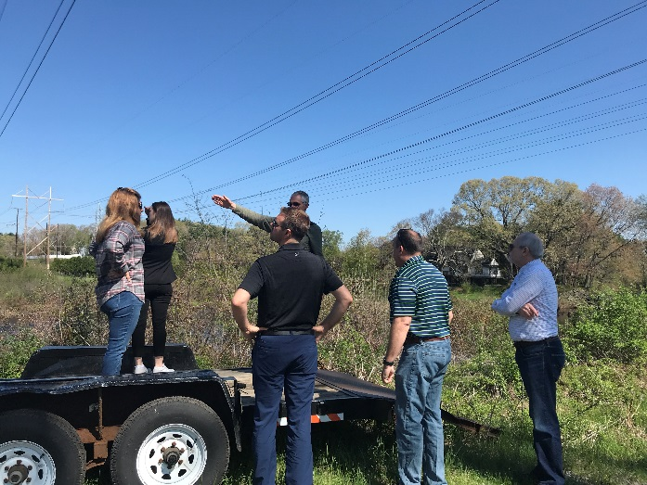

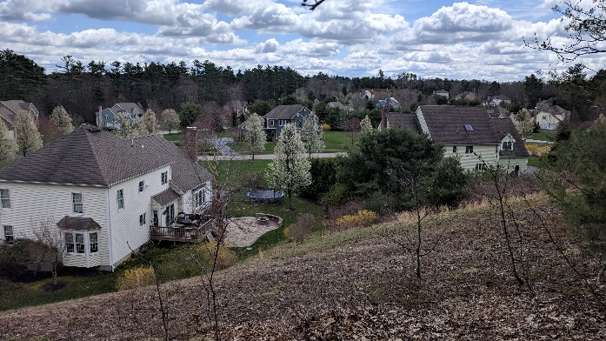
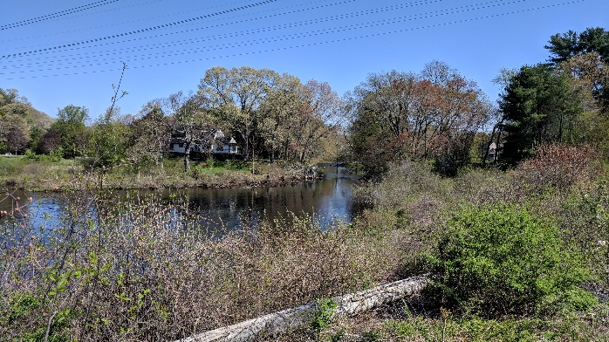

Next Meeting
The next regular SWAP meeting will be a joint SWAP-TRIC Meeting on Tuesday, June 19 from 9:00am-11:00am at the Medfield Public Safety Building. Frances Goyes, MAPC Regional Housing Planner, will be presenting on the outcomes of the Living Little report, which explores a range of small housing typologies. Additionally, we will be voting on our 2018-2019 workplan and electing a new SWAP co-chair.

Respectfully submitted as draft
Kasia Hart
Transportation Policy Associate and SWAP Coordinator

