LYNNSPIRATION: CREATIVE PLACEMAKING IN THE DOWNTOWN LYNN CULTURAL DISTRICT

BACKGROUND
In 2012, the Massachusetts Cultural Council designated a portion of Downtown Lynn as one of the Commonwealth's inaugural Cultural Districts. Although appointed in 2012, the history of arts & culture activism in Downtown Lynn goes back decades. Countless individuals and organizations have contributed their time and energy to Downtown Lynn. The Downtown Lynn Cultural District (DTLCD) is a keeper of this movement and collaborates with cultural partners, both new and well-established, to foster a shared creative and cohesive vision for the city’s cultural community.
Lynn's Cultural District has gained much positive momentum in recent years, and the City is interested and invested in building on the successes of all of the DTLCD cultural partners. Identifying the gateway and boundaries of the DTLCD through creative community placemaking and a unique signature work of art is a critical element of this investment. The signature work of public art, which is the subject of this Call for Artists, should identify the Cultural District and should represent the heart of the community by providing a meaningful display for all Lynn residents to connect to and enjoy. The work of art should act as a magnet, drawing in visitors from surrounding areas and beyond.
In order to progress toward the creation of this artwork and a visually compelling approach to marking district gateways, the City of Lynn Department of Community Development, the Downtown Lynn Cultural District, and the Lynn Public Art Commission has retained the Metropolitan Area Planning Council to develop a Call for Artists and a creative placemaking strategy. To develop the strategy, MAPC is engaging residents, businesses, local institutions, and artists to identify areas of strength, emerging challenges and a shared vision for a compelling work of art that has widespread community support.

Lynn Creative Placemaking Working Group
The Lynn Creative Placemaking Working Group includes representatives from businesses and organizations active in the cultural district and active in promoting arts and culture throughout Lynn. Organizations represented in the group include the Lynn Public Schools Fine Arts Department, Ironbound Marketplace, the New Lynn Coalition, The Brickyard Collaborative, the Food Project and Lynn Farmers Market, North Shore Community College, the Khmer Cultural Planning Committee and Lynn YMCA, as well as working artists.

What Makes Lynn Special?
In thinking about what makes Lynn a special place, this group identified its local pride, its authenticity, and its people, including immigrants, youth, and multi-generational families. The group emphasized the city’s strength and resilience in the face of hardship and challenge. It is important that public art practices in Lynn build on the strength of who is here and connect to the residents of Lynn in a meaningful way. Lynn is a city of hidden assets from its natural resources to its historic artifacts to its multi-ethnic cultural diversity.
PROJECT PARTNERS
The City of Lynn, the Downtown Lynn Cultural District (DTLCD)
Lynn Public Arts Commission (LPAC)
Metropolitan Area Planning Council (MAPC)

LEARN MORE
To learn more about the Lynn Creative Placemaking Project, visit https://www.mapc.org/resource-library/lynn-creative-placemaking/.

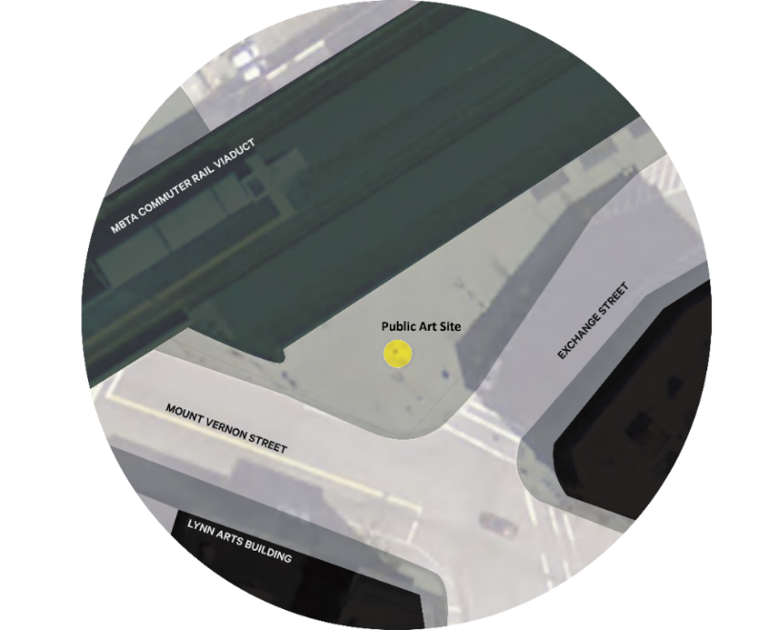
PROJECT AREA MAP

ONGOING WORK OF THE DOWNTOWN LYNN CULTURAL DISTRICT

