Metropolitan Area Planning Council
Fire Apparatus, Emergency Vehicles & Equipment
Ambulances
Request for Proposals
ADDENDA # 1
RFP #FCAM 2021 Ambulances
Solicited on Behalf of the Fire Chiefs Association of Massachusetts
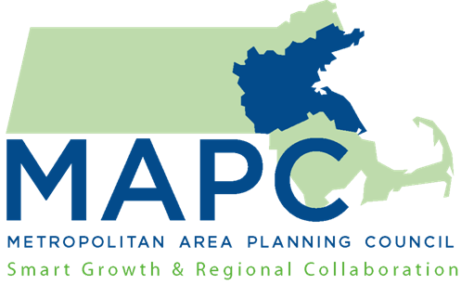

Metropolitan Area Planning Council ● 60 Temple Place, 6th Floor, Boston, MA 02111 ● www.mapc.org ● Main Phone ● 617.933.0700 ● Main Fax 617.482.718Addenda # 1:
- The due date for the RFP has been extended until Friday, October 30, 2020 at 1:00 PM.
- The bidders conference date has been changed to Wednesday, September 2, 2020 at 1:00 PM. The Zoom information is below. We will reissue the information closer to the date to best insure that prospective vendors receive the information.
MAPC Zoom Line 1 is inviting you to a scheduled Zoom meeting.
Topic: FCAM 2021 Ambulances Vendor Conference
Time: Sep 2, 2020 01:00 PM Eastern Time (US and Canada)
Join Zoom Meeting
https://zoom.us/j/97812679963
Meeting ID: 978 1267 9963
One tap mobile
+16468769923,,97812679963# US (New York)
+13017158592,,97812679963# US (Germantown)
Dial by your location
+1 646 876 9923 US (New York)
+1 301 715 8592 US (Germantown)
+1 312 626 6799 US (Chicago)
+1 346 248 7799 US (Houston)
+1 408 638 0968 US (San Jose)
+1 669 900 6833 US (San Jose)
+1 253 215 8782 US (Tacoma)
Meeting ID: 978 1267 9963

All remaining language in the RFP remain unchanged.

