### LYNNSPIRATION: CREATIVE PLACEMAKING IN THE DOWNTOWN LYNN CULTURAL DISTRICT

### BACKGROUND

In 2012, the Massachusetts Cultural Council designated a portion of Downtown Lynn as one of the Commonwealth's inaugural Cultural Districts, honoring the history of arts & culture activism in Downtown Lynn that goes back decades. Countless individuals and organizations have contributed their time and energy to Downtown Lynn. The Downtown Lynn Cultural District (DTLCD) is a keeper of this movement and collaborates with cultural partners, both new and well-established, to foster a shared creative and cohesive vision for the city’s cultural community.

Lynn's Cultural District has gained much positive momentum in recent years, and the City is interested and invested in building on the successes of all of the DTLCD cultural partners. Identifying the gateways and boundaries of the DTLCD through creative community placemaking and a unique signature work of art is a critical element of this investment.

In order to progress toward the creation of this artwork and a visually compelling approach to community creative placemaking in the district, the City of Lynn Department of Community Development, the Downtown Lynn Cultural District, and the Lynn Public Art Commissionhave retained the Metropolitan Area Planning Council to develop a Call for Artists and a creative placemaking strategy. To develop the strategy, MAPC is engaging residents, businesses, local institutions, and artists to identify areas of strength, emerging challenges and a shared vision for a compelling work of art that has widespread community support.

### Lynn Creative Placemaking Working Group

The Lynn Creative Placemaking Working Group has provided guidance to this project. It includes representatives from businesses and organizations active in the cultural district and active in promoting arts and culture throughout Lynn. Organizations represented in the group include the Lynn Public Schools Fine Arts Department, Ironbound Marketplace, the New Lynn Coalition, The Brickyard Collaborative, the Food Project and Lynn Farmers Market, North Shore Community College, the Khmer Cultural Planning Committee and Lynn YMCA, as well as working artists.

### Deliverables

This project will result in an artist and concept selection process informed by values identified by the Lynn Creative Placemaking Working Group: engagement/interaction, multi-generational, education, justice, support of Lynn residents and artists, positivity and joy, and vividness. A creative placemaking strategy will identify opportunities for arts and culture to activate and enhance public spaces throughout the cultural district.

**PROJECT PARTNERS**

The City of Lynn, the Downtown Lynn Cultural District (DTLCD)

Lynn Public Arts Commission (LPAC)

Metropolitan Area Planning Council (MAPC)

### LEARN MORE

To learn more about the Lynn Creative Placemaking Project, visit <https://www.mapc.org/resource-library/lynn-creative-placemaking/>.

### PROJECT AREA MAP

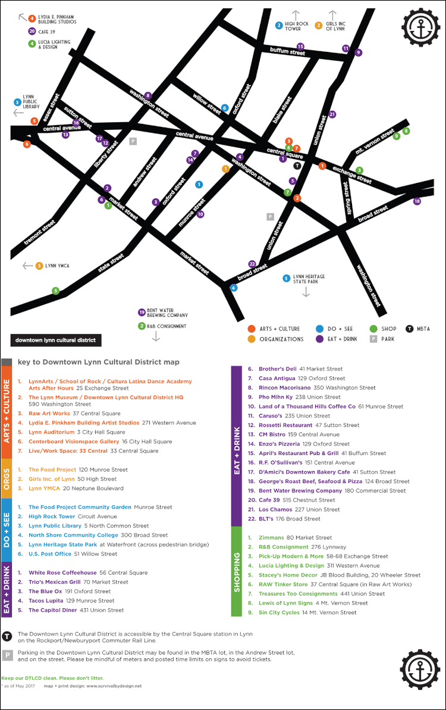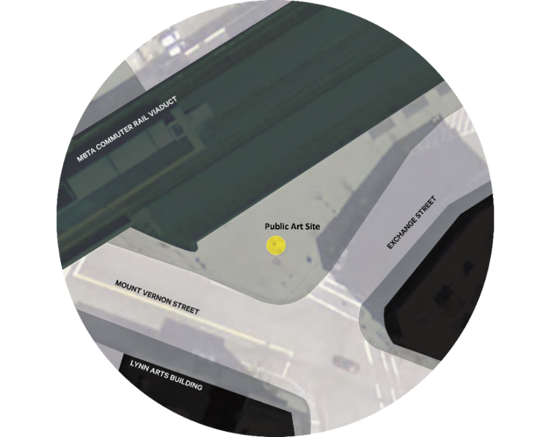

**ONGOING WORK OF THE DOWNTOWN LYNN CULTURAL DISTRICT**

Downtown Lynn continues to grow as a vibrant, arts-rich community. Lynn is one of only six communities across the Commonwealth to be named a Cultural Compact City in partnership with the Mass Cultural Council. This program has enabled the Downtown Lynn Cultural District (DTLCD) to partner with the Lynn Cultural Council and the City of Lynn Mayor's Office to pursue a shared and inclusive vision of the importance of our local cultural sector.

The mission of the DTLCD is to make art and culture accessible to all. The organization strives to promote local economic activity and contribute to a positive perception of Downtown, marketing it as a unique urban environment with arts and culture at its core. We act as a connector and unifier providing resources and collaborative opportunities, and we are earning a seat at the table to help arts and culture thrive across the Commonwealth.

To date, the DTLCD has renewed its cultural district status, expanded its cultural footprint and created an incomparable cohort of partnerships and collaborators. We have established and launched the City's Public Arts Commission, seeded and incubated programs such as Rock the Block, Third Thursdays, Creator Conversations, Music in the Farmer's Market and Clock to the Rock 5K. We've expanded on programming such as citywide Open Studios, historic trolley tours and local Trails+Sails events. We offer local grant opportunities to local organizations that expand our reach beyond the boundaries of the cultural district.

The current 'city hALL' initiative was created in partnership with the City and its residents to strengthen the community presence and voice in *their* civic building, to educate visitors about Lynn's history, and to celebrate our diversity. DTLCD is establishing partnerships with the Lynn Public Schools to implement curriculum geared towards educating and celebrating our local students' cultural heritage, creating a path for our next generation to feel celebrated and empowered, and in turn, continuing our City's legacy of welcoming and honoring our vibrant and industrious people.