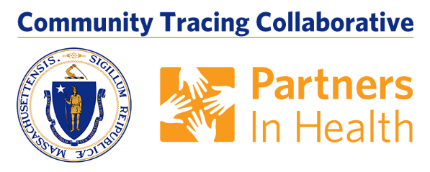

Thank you for your help in spreading the word about contact tracing in Massachusetts. Along with testing and social distancing, contact tracing is an important part of continuing to stop the spread of COVID-19 in Massachusetts.

We have put together a small toolkit of material, including social media-ready messages and images you can use to help spread the word about the importance of contact tracing.

Attached is a document that includes some language for use in newsletters, blogs, websites and other platforms you use to communicate with your constituents. Also attached are images with English and Spanish language for your use. Below are some suggested social media messages that can be used with the attached images.

Option #1 (209 Characters)
Answer the call and stop the spread of COVID-19. If you get a call from the MA COVID Team with area codes 833 or 857, answer the call and help our contact tracing effort. Learn more at mass.gov/matracingteam.

Option #2 (212 Characters)
Help our community stop the spread of COVID-19 by answering the call from the MA COVID Team. Look for calls from the team with area codes 833 or 857 and help our contact tracing team stop the spread of the virus.

Option #3 (214 Characters)
Along with social distancing and testing, contact tracing is a vital part of reducing the spread of COVID-19. If you get a call from the MA COVID Team from area codes 833 or 857, answer the call and play your part.

